**SQL ASSIGNMENTS**

Create a database worker that should contain **first name, last name email, department, salary, Join Date** with 50 employees.

Db creation:

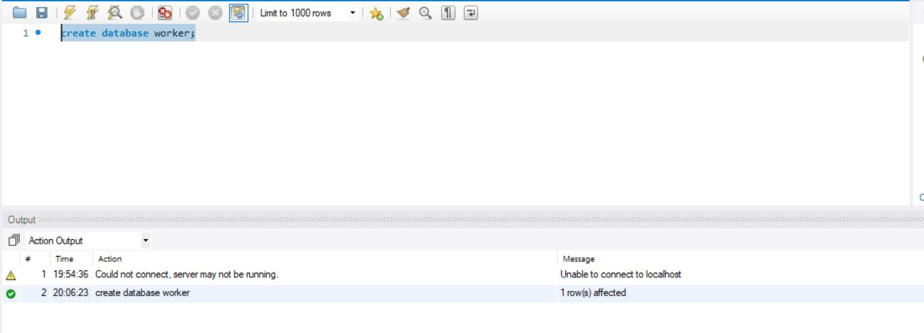

Table creation:

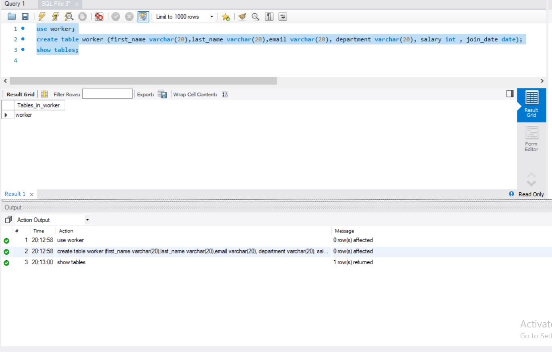

Inserting rows with worker details:

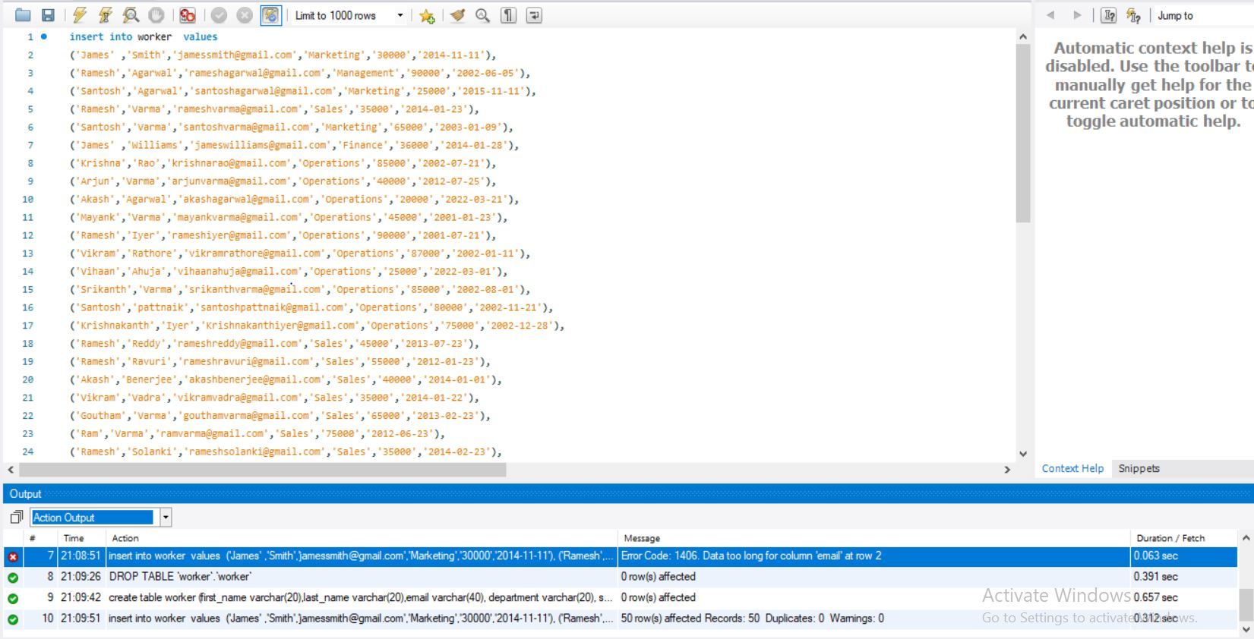

**Task-1**

1. Write an SQL query to fetch “FIRST_NAME” from the Worker table using the alias name as <WORKER_NAME>.

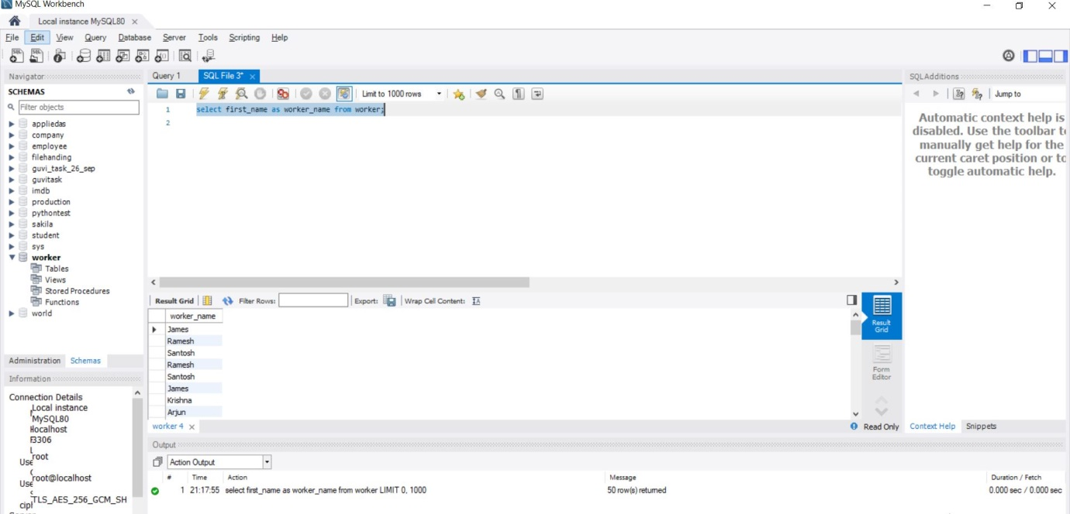

1. Write an SQL query to fetch unique values of DEPARTMENT from the Worker table.

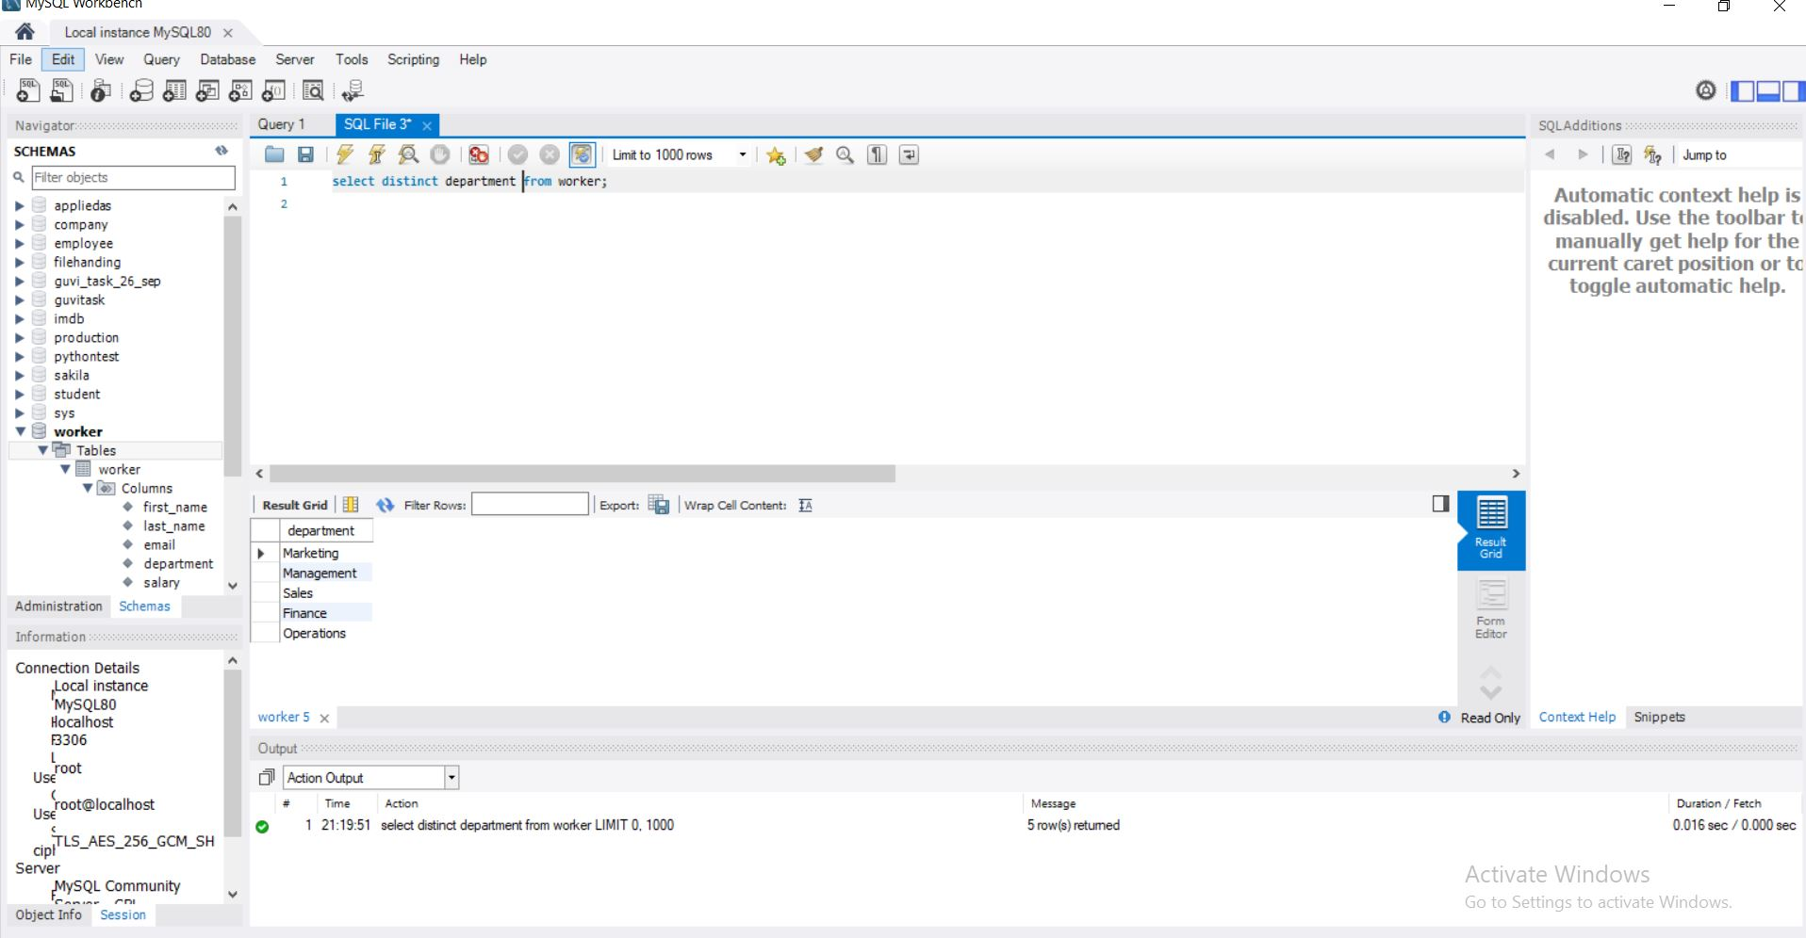

1. Write an SQL query to show the last 5 records from a table.

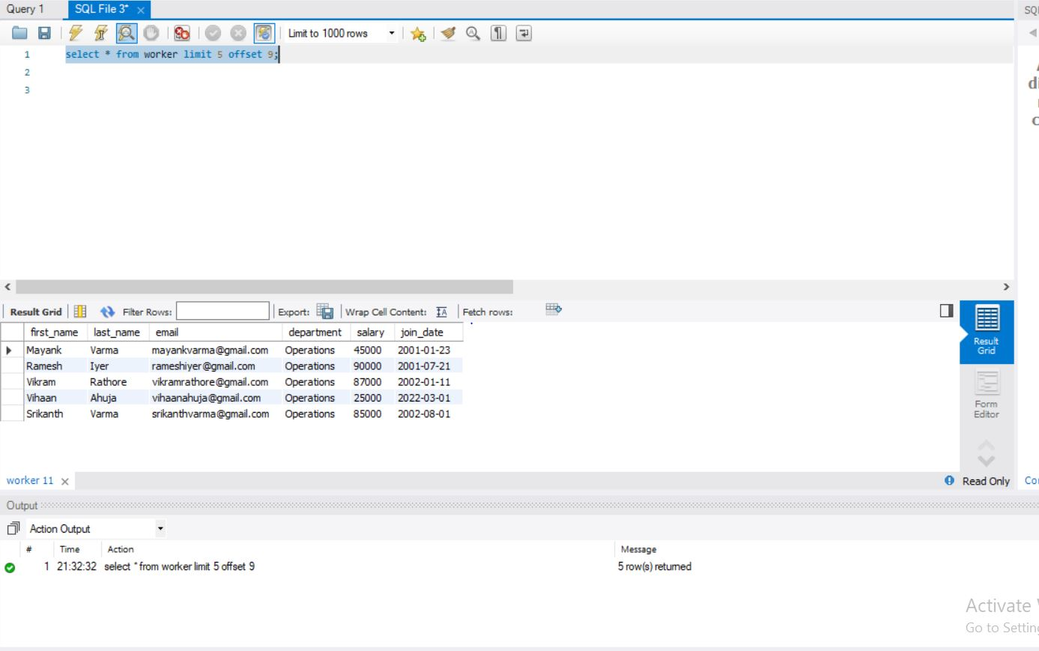

**Task-2**

1. Write an SQL query to print the first three characters of FIRST_NAME from Worker.

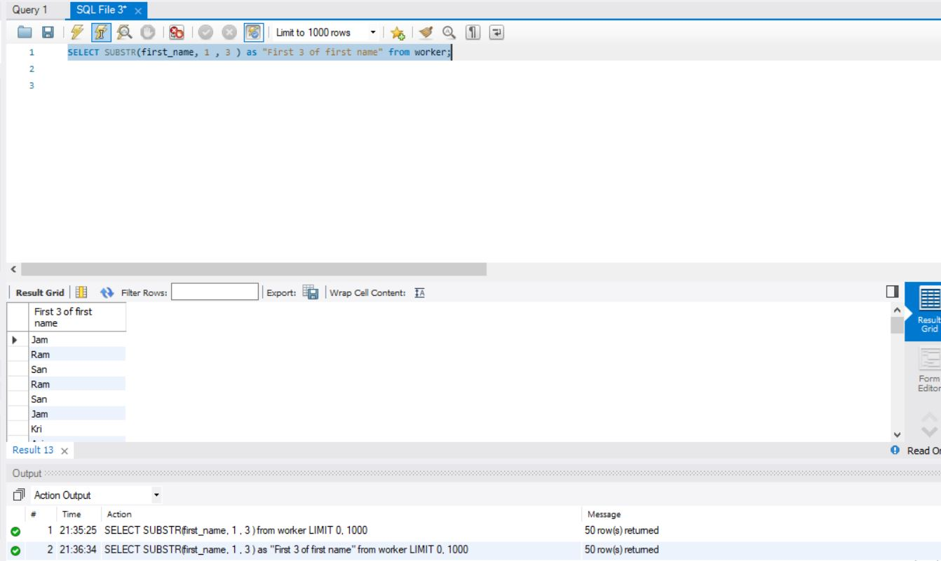

1. Write an SQL query to find the position of the alphabet (‘a’) in the first name

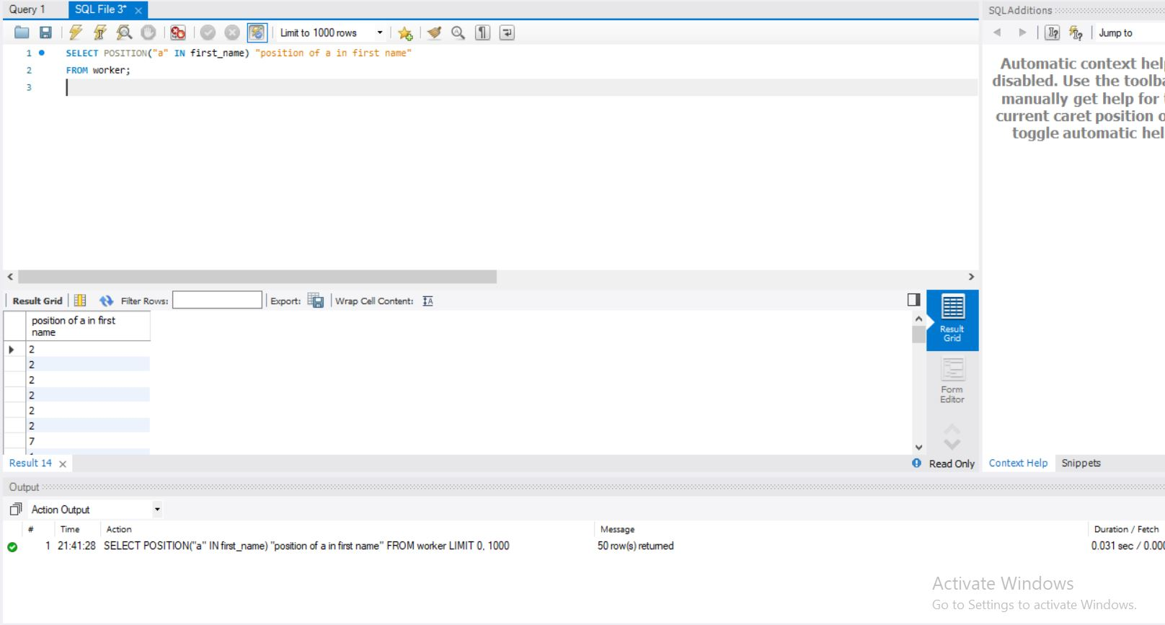

1. Write an SQL query to print the name of employees who have the highest salary in each department.

**Task-3**

1. Write an SQL query to print the FIRST_NAME from the Worker table after removing white spaces from the right side.
2. Write an SQL query that fetches the unique values of DEPARTMENT from the Worker table and prints its length.
3. Write an SQL query to fetch nth max salaries from a table.

**Task-4**

1. Write an SQL query to print the FIRST_NAME from the Worker table after replacing ‘a’ with ‘A’.
2. Write an SQL query to print all Worker details from the Worker table order FIRST_NAME Ascending and DEPARTMENT Descending.
3. Write an SQL query to fetch the names of workers who earn the highest salary.

**Task-5**

1. Write an SQL query to print details of workers excluding first names, “Ramesh” and “Santhosh” from the Worker table.
2. Write an SQL query to print details of the Workers whose FIRST_NAME ends with ‘h’ and contains six alphabets.
3. Write a query to validate Email of Employee (email should have first name last name and guvi.com example (first name=Kamal last name= raja and the mail id should be [kamalraja@guvi.com](mailto:kamalraja@guvi.com)).

**Task-6**

1. Write an SQL query to print details of the Workers who have joined in March ’2021.
2. Write an SQL query to fetch duplicates that have matching data in some fields of a table.
3. How to remove duplicate rows from the Employees table.

**Task-7**

1. Write an SQL query to show only odd rows from a table.
2. Write an SQL query to clone a new table from another table.

**Task-8**

1. Write an SQL query to fetch intersecting records of two tables.
2. Write an SQL query to show records from one table that another table does not have.

**Task-9**

1. Write an SQL query to show the top n (say 15) records of a table.
2. Write an SQL query to determine the nth (say n=10) highest salary from a table.

**Task-10**

1. Write an SQL query to determine the 8th highest salary without using TOP or LIMIT methods.
2. Write an SQL query to fetch the list of employees with the same salary.

Attach the query with the output table screenshot with the assignment.